**TASK # 1**

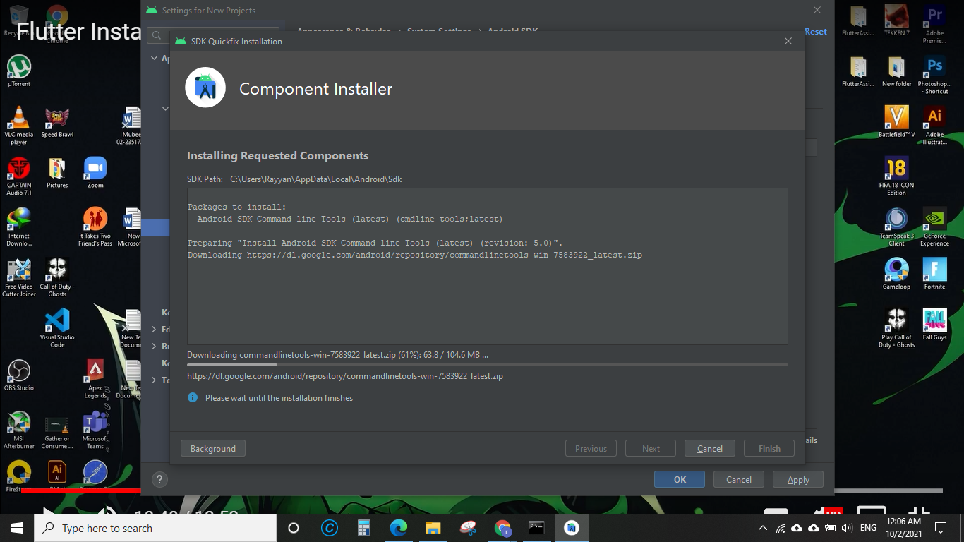

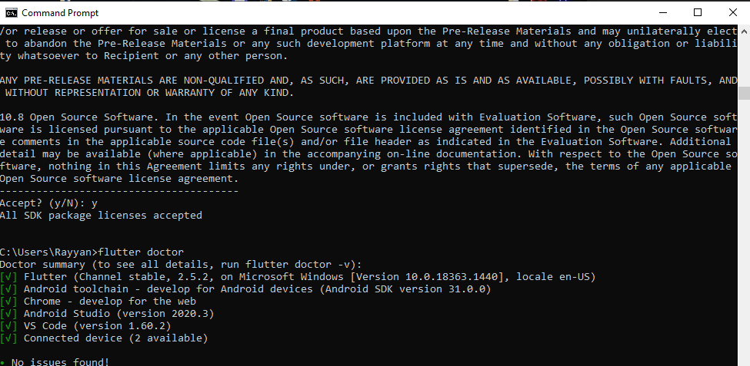

**TASK # 2**

void main() {

tab_fn(4);

}

void tab_fn(int num) {

for (int i = 1; i < 11; i++) {

print("$num * $i = ${num * i}");

}

}

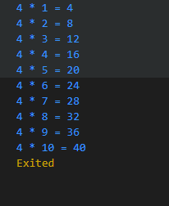

**TASK # 3**

void main() {

function(8);

}

void function(num number) {

List<dynamic> lst = [2, 4, 6, 8, 9];

for (int i = 0; i < lst.length; i++) {

print("${number / lst[i]}");

}

}

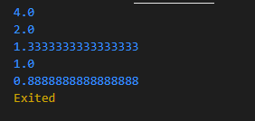

**TASK # 4**

void main() {

mark_sheet();

}

void mark_sheet() {

List<dynamic> names_lst = ['Rayyan', 'Qasim', 'Sajid', 'Akram', 'Bilal'];

List<dynamic> father = ['Riaz', 'Javed', 'Qadir', 'Ghulam', 'Shaheen'];

List<dynamic> m_m = [65, 65, 0, 32, 48];

List<dynamic> e_m = [44, 72, 0, 72, 70];

List<dynamic> u_m = [50, 72, 0, 32, 64];

List<dynamic> p_m = [58, 65, 0, 16, 61];

List<dynamic> c_m = [56, 65, 0, 35, 60];

var clas = 9;

var sec = 'A';

var total_num_of_sub = 5;

num add = 75 * total_num_of_sub;

int t = 75;

for (int i = 0; i < names_lst.length; i++) {

num sum = m_m[i] + e_m[i] + u_m[i] + p_m[i] + c_m[i];

num per = (sum / add) * 100;

var a = per.toStringAsFixed(2);

print("*" * 50);

print("*" * 50);

print("*" * 50);

print("* Canadiate : ${names_lst[i]} S/O: ${father[i]}*");

print("* Class : $clas Section: $sec *");

print("*" * 50);

print("");

print("Number of Maths: ${m_m[i]} / $t");

print("Number of English: ${e_m[i]} / $t");

print("Number of Urdu: ${u_m[i]} / $t");

print("Number of Physics: ${p_m[i]} / $t");

print("Number of Chemistry: ${c_m[i]} / $t");

print("*" * 50);

print(" TOTAL $sum/ $add");

print(" Percentage $a%");

if (per > 80) {

print(" Grade A+ ");

} else if (per >= 70 && per < 80) {

print(" Grade A ");

} else if (per >= 60 && per < 70) {

print(" Grade B ");

} else if (per >= 50 && per < 60) {

print(" Grade C ");

} else {

print("FAIL");

}

}

}

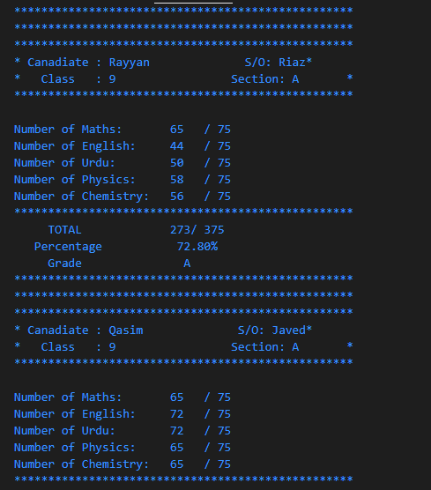

**TASK # 5**

//Task 5

void main() {

Abc obj = new Abc();

obj.abc_fn();

obj.abc_fn2(7);

}

class Abc {

void abc_fn() {

print("This is simple function");

}

void abc_fn2(int num) {

print("You favourite num is $num");

}

}

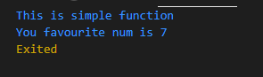

**TASK # 6**

void main() {

Student_Name obj = Student_Name();

obj.setnamef("Riaz Alam");

obj.setname("Muhammad Rayyn");

print("My name is ${obj.getname()} ${obj.getnamef()}");

}

class Father_name {

late String fat_name;

void setnamef(String f_name) {

fat_name = f_name;

}

String getnamef() {

return fat_name;

}

}

class Student_Name extends Father_name {

late String std_name;

void setname(String name) {

std_name = name;

}

String getname() {

return std_name;

}

}

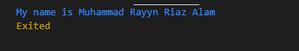

**TASK # 7**

main() {

//object

MyInfo obj = MyInfo(name: "Rayyan", age: 21, education: "BSCS");

obj.sayInfo();

}

class MyInfo {

int age;

String name;

var education;

//constuctor

MyInfo({required this.name, required this.age, required this.education});

//method

void sayInfo() {

print("My name is: $name");

print("My age is: $age");

print("My Education: $education");

}

}

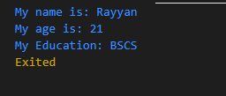

**TASK # 8**

void main() {

Student_Name obj = Student_Name();

obj.setnamef("Riaz Alam");

obj.setname("Muhammad Rayyn");

print("My name is ${obj.getname()} ${obj.getnamef()}");

}

class Father_name {

late String fat_name;

void setnamef(String f_name) {

fat_name = f_name;

}

String getnamef() {

return fat_name;

}

}

class Student_Name extends Father_name {

late String std_name;

void setname(String name) {

std_name = name;

}

String getname() {

return std_name;

}

}

